Contact us fragment

Contact us is a simple screen that allow the user to send feedback about the application to us. Also, it allows the user to email us by only clicking on the email on the screen the application will open a list of email application on the phone so the user can choose one, figure x shows the list of email clients application on the phone so the user can choose his favourite. after choosing one every thing will be set no need to insert our email once more. These two methods are useful to keep improving the application and to know what the users like or hate about the application.

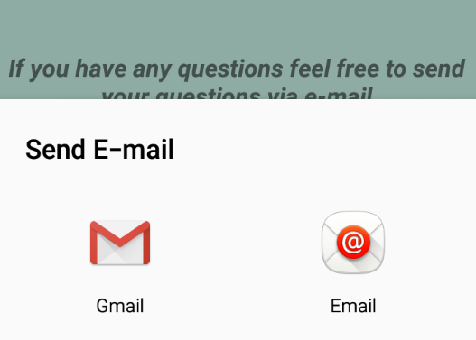

Figure x:

The fragment is designed to be as simple as possible, figure x shows the layout of the fragment

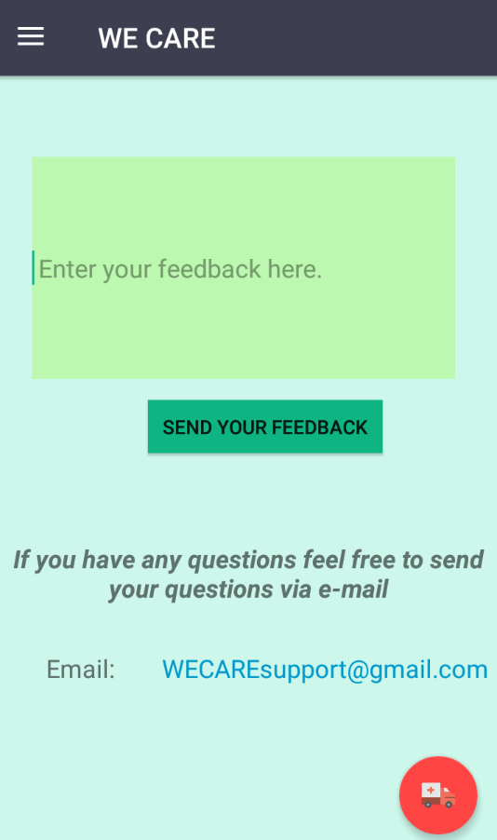

Options under others section

Settings Fragment

Settings fragment is designed to give the user more options and control over the application. Right now, the settings layout gives the user the option to choose what number to be called when the emergency button is pressed or when the measurements state is dangerous. Figure x shows the settings screen.

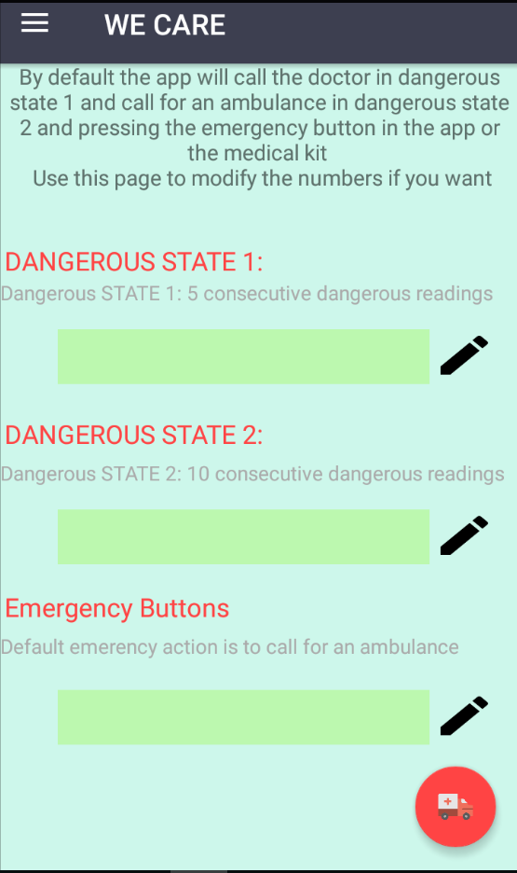

Figure x: GUI for settings fragment

By default, the app will call an ambulance if the emergency button is pressed or the measurements are in dangerous state 2 and calls the doctor if the measurements in dangerous state 1. And by clicking the edit button after inserting the number he wants he can change the default numbers.

Also, a feature we didn’t have the time to finish is to provide an Arabic version of the app, the language options will be added in the settings screen upon completion

About the App Fragment

The about the app option uses a very simple fragment that inflates a layout containing information about the application and the project in general. Figure x shows the layout. Also the user can find a text that leads him to the contact us screen to submit questions or feedback.

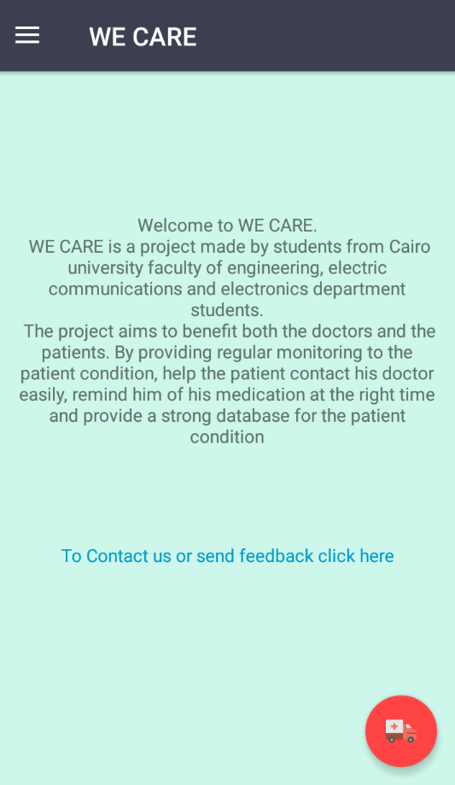

Figure x: about the app layout

Logout

The logout option does a simple job it clears the user related data that was stored during the period where the user was logged in whether its stored-on SQLite tables or using shared preferences.

This action will also take the user back to the registration screen and to use the app features again a login is required.